This institution is an equal opportunity provider.

Corn Dogs
Fresh Veggie
Fresh Fruit

Carlos Pizza
Fresh Veggie
Fresh Fruit

French Toast Sticks
Fresh Veggie
Fresh Fruit
Mini Buns

Nachos w/meat &
Cheese
Fresh Veggie
Fresh Fruit
Tortilla Chips & Salsa

Taco w/meat & Cheese
Fresh Veggie
Fresh Fruit

Carlos Pizza
Fresh Veggie
Fresh Fruit

WG Ravioli
w/meatsauce
Fresh Veggie
Fresh Fruit
Bosco Stick

Italian Sub on WG Bun
Fresh Veggie
Fresh Fruit
Cookie

Chicken Tenders
Fresh Veggie
Fresh Fruit

Carlos Pizza
Fresh Veggie
Fresh Fruit

Shrimp Poppers
Fresh Veggie
Fresh Fruit
Goldfish Crackers

Grilled Cheese on WG
Bread
Fresh Veggie
Fresh Fruit
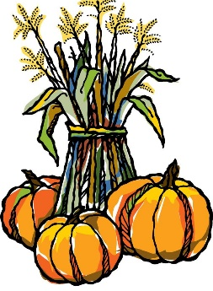

Taco w/meat & cheese
Fresh Veggie
Fresh Fruit

Ham & Cheese Salad
w/tomatoes
Fresh Veggie
Fresh Fruit
Dinner Roll

Carlos Pizza
Fresh Veggie
Fresh Fruit

Macaroni & Cheese
Fresh Veggie
Fresh Fruit
Bosco Stick

Italian Sub on WG Bun
Fresh Veggie
Fresh Fruit
Cookie

BBQ Chicken Flatbread
w/red onion
Fresh Veggie
Fresh Fruit
Goldfish Crackers

Chicken Nuggets
Fresh Veggie
Fresh Fruit

Popcorn Chicken Bowl
w/ corn, mashed potatoes w/gravy
Fresh Fruit

Frito Chili Cheese Bags
Fresh Veggie
Fresh Fruit
Cookie
OCTOBER CALENDAR
Oct 4-15 NWEA/MAP
Testing
Oct 6 Chapel 8:20a
(Parents Welcome!)
Count Day
Oct 10 Gr 3 & 4 Choir
sing @ 11a Worship
Oct 13 Chapel 8:20a
(Parents Welcome!)
Oct 20 Chapel 8:20a
(Parents Welcome!)
Oct 21-24 Gr 8 Camp Arcadia
Oct 27 Reformation Chapel
8:20a (Parents Welcome!)
Oct 31 Gr 7/8 Choir sing @
9a Worship
Reformation Sunday

Milk included w/lunch
Ala carte -35₵

Low-fat-unflavored 1%
Nonfat-unflavored
Nonfat-chocolate

Daily Special Entrée Options
Egg & Cheese Omelet
or
Hot Dog on WG Bun

